Capstone Project Weekly Progress Report
Semester | Fall-2024 Semester 3rd
Course Code | AML-3406
Section | Section 1
Project Title | Car Damage Detection
Group Name | Group B
Student names/Student IDs | Sakshi (C0908000) – TL  Bansil Patel (C0912873)  Harsh Mohile (C0912872)  Meet Patel (C0910378)  Rachit Bhatt (C0902810)
Reporting Week | Week 1
Faculty Supervisor | William Pourmajidi

Grade the level of collaboration from different aspects between team members:
(use: good, medium, below expectation)
Sakshi | Bansil Patel | Harsh Mohile | Meet Patel | Rachit Bhatt
Good | Good | Good | Good | Good

Tasks outlined in the previous Weekly Progress Report for this reporting week at the individual level and group level
  - Individual tasks (each team member)
Sakshi: Documentation and formatting of weekly reports and the proposal.
Bansil Patel: Explore various project topics and finalize the best one.
Harsh Mohile: Research libraries and packages.
Meet Patel: Research on dataset related to the topic.
Rachit Bhatt: Research on deployment standards.
2.2 Your team’s tasks
- Made significant efforts to lay the foundation of our capstone project on car damage detection.
- Began by forming our team and conducting thorough research on cutting-edge machine-learning projects across different sectors, such as banking, education, and retail.
- Reviewed numerous advanced topics during our class discussions and consulted with our professor to refine our project focus.
- Although working on various machine learning projects over the past two semesters, we tried to beat a fresh challenge this time.
- Finalized to propose and pursue car damage detection.
- Explored several algorithms, including CNN and YOLO, to determine their potential effectiveness for our project.
- We also identified suitable datasets and shared our findings through GitHub and a Slack group to ensure efficient collaboration and information sharing.

Progress made in Reporting Week at an individual level and group level
  - Individual progress
Sakshi: Made weekly progress report for week 1.
Bansil Patel: Researched multiple project domains and defined their challenges and scope.
Harsh Mohile: Gathered information about various Python modules.
Meet Patel: Explored datasets on all topics.
Rachit Bhatt: Analyzed deployment standards on all topics and finishing weekly report.
  - Your team’s progress
- Explored various project domains.
- Assessed project challenges and scopes to pinpoint the most viable options.
- Compiled information on various Python modules and their potential applications.
- Selected relevant datasets related to current trends and reviewed deployment standards for different topics to ensure a smooth implementation process as we advance.

The areas/tasks you could not make progress and/or complete as scheduled or the difficulties encountered in this reporting week at individual level and group level.
As this was our first week, there were not much challenges encountered when searching or identifying the problem and reporting the progress.
  - Individual project blockers
Sakshi: N/A
Bansil Patel: Identifying the best project to work on.
Harsh Mohile: N/A
Meet Patel: N/A
Rachit Bhatt: N/A
  - Your team’s project blockers
- Identifying the most current and relevant project topics was particularly challenging, as it involved extensive research and evaluation.
- Finding appropriate algorithms, datasets, and deployment standards required careful consideration to ensure they met our project needs.

Tasks to be completed in next week at individual level and group level
  - Individual tasks
Sakshi: Document the proposal with proper formatting and make project icon.
Bansil Patel: Research project domain and define resource allocation.
Harsh Mohile: Study on ML-Ops.
Meet Patel: Select the dataset.
Rachit Bhatt: Configure GitHub.
  - Your team’s tasks
- Thoroughly studying and documenting our project proposal.
- Focusing on identifying and strategizing ways to tackle potential challenges.
- Designing an effective approach for training and testing our model to maximize accuracy, including examining best practices, fine-tuning our methods, and preparing for the subsequent phases.

Include the tasks from your sprint planning (Github/Zenhub) for the present period.
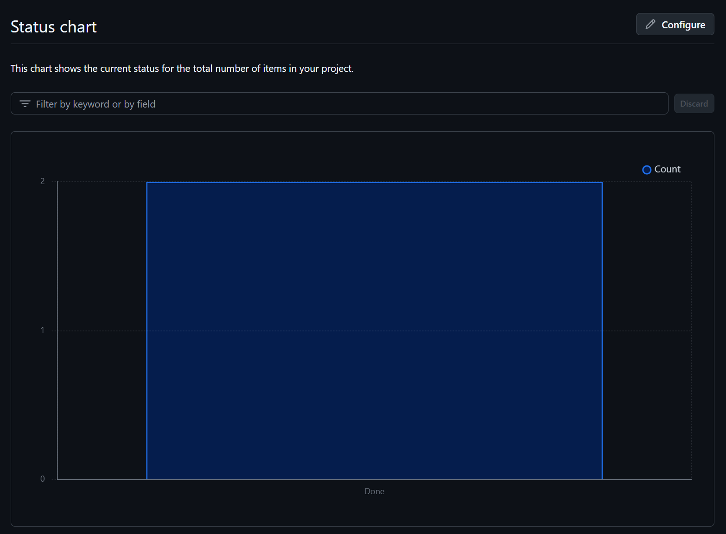
Figure 1: Status Chart of GitHub Issues in Milestone

Include charts/graphs (e.g., burn down charts) from your project management tool (Github/Zenhub) that shows your progress for the period of this report.
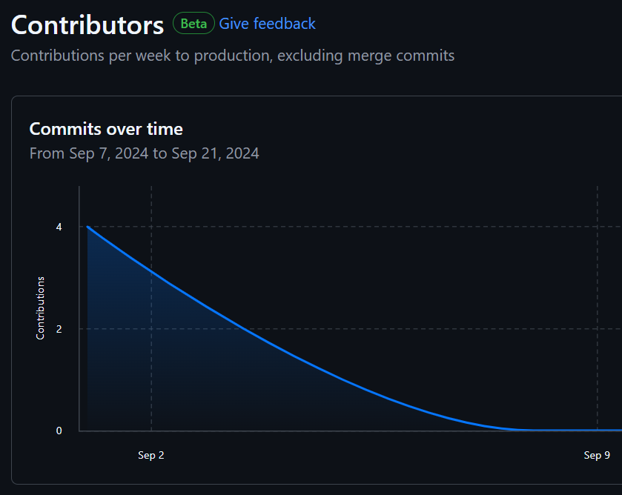
Figure 2: Highest Contributor of the Week

Include a note and address to your project Github with list of codes uploaded/updated on Github in this reporting week.
In the first week, our team focused on selecting a suitable topic. Then we searched for various algorithms, libraries, and packages required accordingly. Hence, there were no coding practices involved in this week.
GitHub: https://www.github.com/rachit-bhatt/Capstone-Project

